**ARRAY2D – REVIEW**

**Exercise 1:**

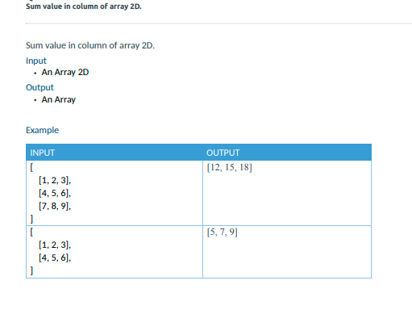

1. Why do we need two loops in this exercise?

Because we need sum of column so we nee to loop to access column.

1. Why the first loop range is Array2D [0]?

Because we need to loop column.

1. Why do we need to append the result to a new array?

Because we need to append to vibrable array.

1. Why don’t we use str (input ()) or int (input ()) to get list of arrays from terminal?

Because it is array2D.

**Exercise 2:**

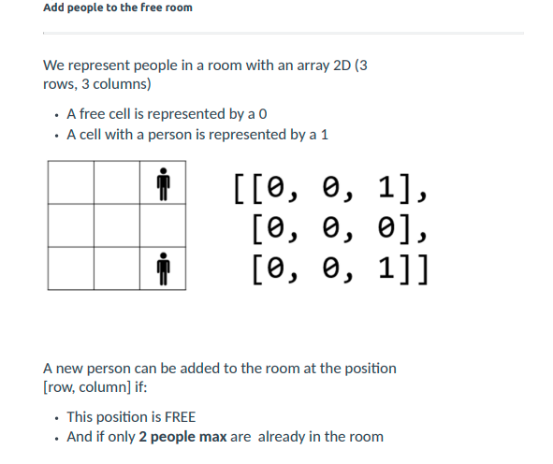

Example:

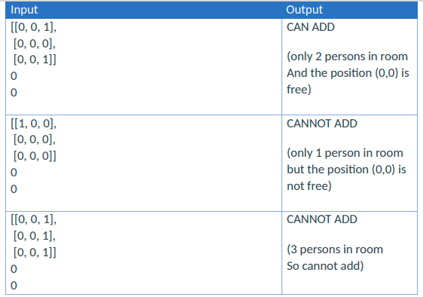

1. Why does this exercise need to create a function?

Because we need to call function and reduce code.

1. what is the purpose of that function?

can pass data, known as parameters, into a function. A function can return data as a result.

1. why do we need to use a loop in loop in an array?

Because we need to access to row and column .

1. what is the value of the variable peopleInRoom?

Value of append row and column .

1. why we need to use if len(peopleInRoom) >=3: ?

because we need to count number in peopleInRoom.

1. On else condition, why do we need to loop again?

Because we need to loop value in peopleInRom to compare input newPersonRow and newPersonColumn.

1. why do we need the variable isCanAdd?

Because if when we compare we nee True and False so We need to create It.

**Exercise 3:**

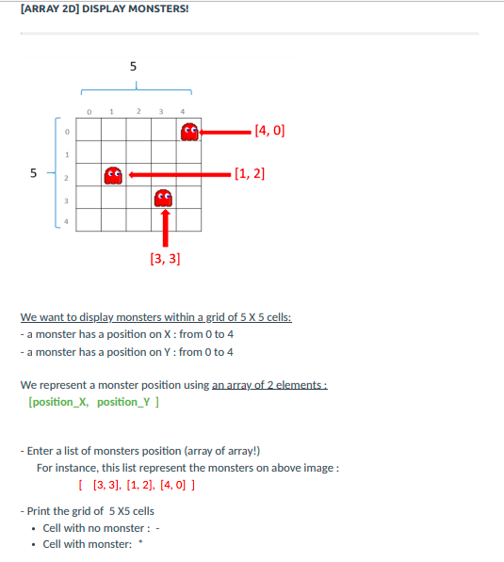

**0**

Result:

0 0 0 0 *

0 0 0 0 0

0 * 0 0 0

0 0 0 * 0

0 0 0 0 0

1. Why does this exercise need to create a function?

Easy to call function and reduce code

1. what is the purpose of that function?

Find row and column wee should add 0 or *.

1. What are the parameters in that function?

The parameters in this function are monsterPosition, cellX, cellY.

1. Why do we need a loop of loop outside the function?

Because we need to create grid that has 5row and 5column and insert.

1. Why do we need to call function while we are looping?

Because we need to insert position of values that input.

1. Why the result variable needs to sum by “\n”?

Because we have to enter the line when we add.